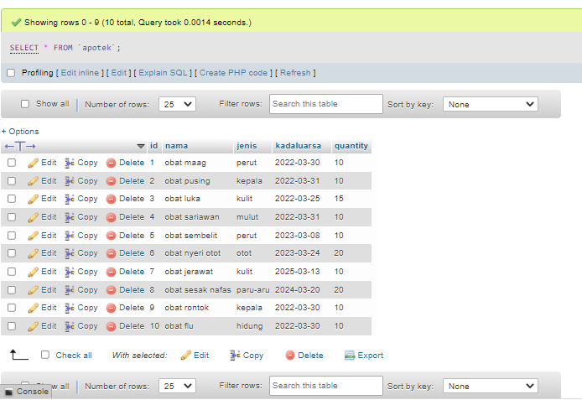

SELECT * FROM ‘apotek’

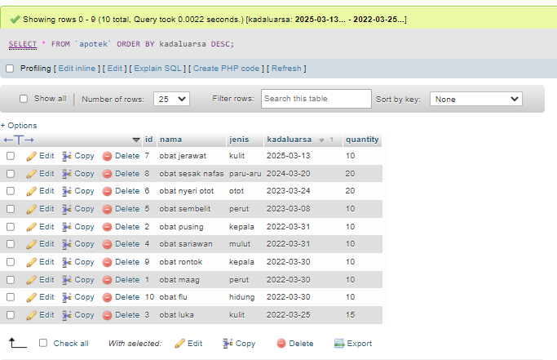

SELECT * FROM `apotek` ORDER BY kadaluarsa DESC

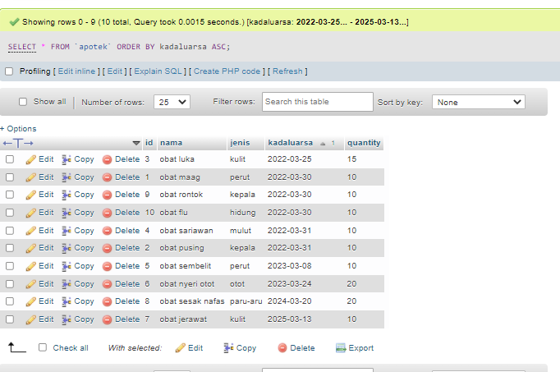  
SELECT * FROM `apotek` ORDER BY kadaluarsa ASC

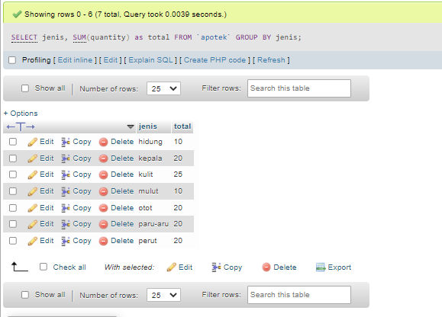

SELECT jenis, SUM(quantity) as total FROM `apotek` GROUP BY jenis

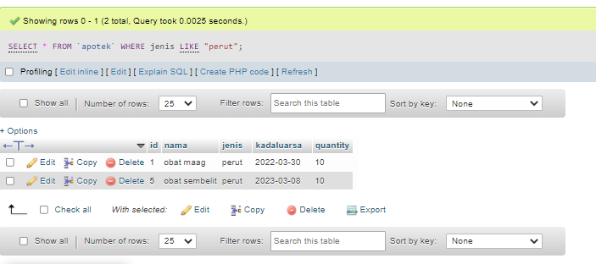

SELECT * FROM `apotek` WHERE jenis LIKE "perut"

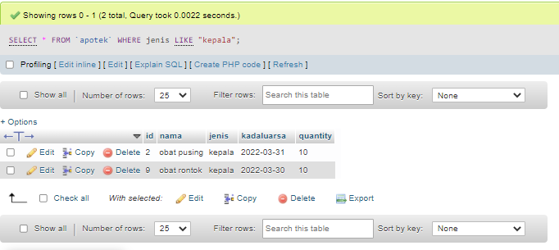

SELECT * FROM `apotek` WHERE jenis LIKE "kepala"

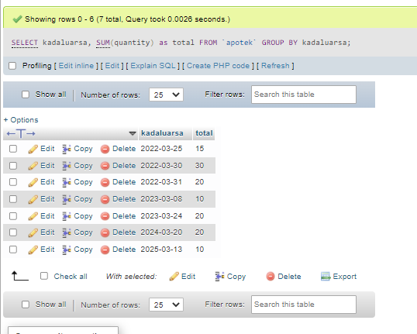

[SELECT](http://localhost/phpmyadmin/url.php?url=https://dev.mysql.com/doc/refman/8.0/en/select.html) kadaluarsa, [SUM](http://localhost/phpmyadmin/url.php?url=https://dev.mysql.com/doc/refman/8.0/en/group-by-functions.html#function_sum)(quantity) as total FROM `apotek` GROUP BY kadaluarsa

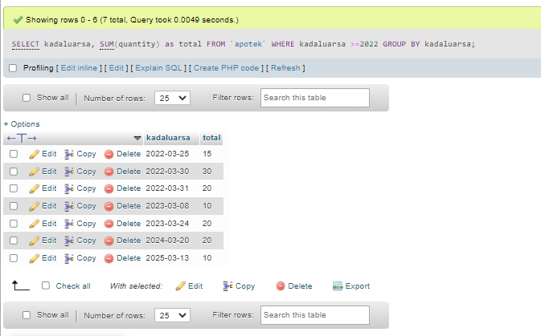

SELECT kadaluarsa, SUM(quantity) as total FROM `apotek` WHERE kadaluarsa >=2022 GROUP BY kadaluarsa

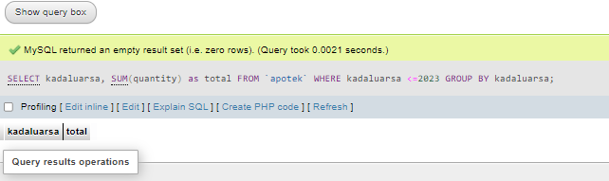

SELECT kadaluarsa, SUM(quantity) as total FROM `apotek` WHERE kadaluarsa <=2023 GROUP BY kadaluarsa

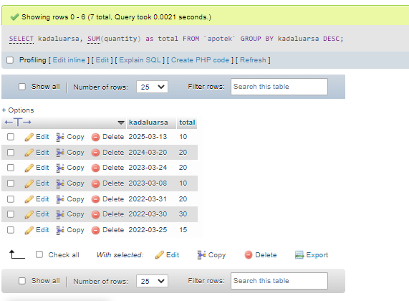

SELECT kadaluarsa, SUM(quantity) as total FROM `apotek` GROUP BY kadaluarsa DESC